Save Our Pollinators  Heal Our Ecosystem  Create Habitat  - Choose native plants  - Include butterfly host plants  - Avoid hybrid or cultivar varieties  - Limit the use of herbicides and pesticides  - Choose a variety of spring, summer, and fall blooming plants  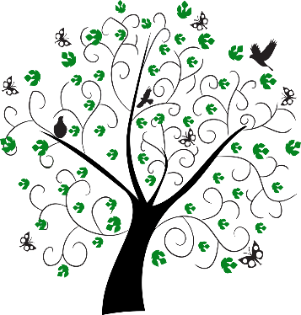  - Reduce the size of your lawn  - Avoid fabric, rock, or thick mulch  - Use native undercover plants to prevent weeds  - Wait until late April to do a yard clean up  - Leave old stems until spring  - Let fallen leaves remain in plant beds over winter  - Use motion sensor, yellow, or LED lights outdoors
  Be Part of the Solution
  Plant Native
  Join Sag Moraine
  Donate to Sag Moraine
  Volunteer with Sag Moraine
  At
  sagmoraine.org
  We Need You!
  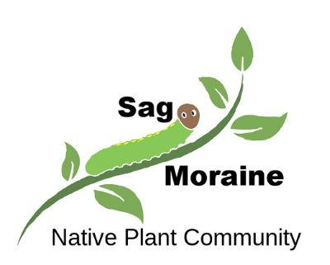
  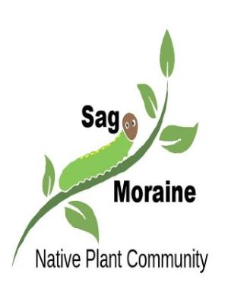
  Restoring Our Environment…One Plant at a Time
  Sag Moraine is an all-volunteer, non-profit 501(c)3 environmental organization. Our mission is to promote the use of native plants and ecological landscaping in our community.

Plant Native  Native plants have co-evolved with other organisms over thousands of years to form an ecosystem. Non-native plants have been introduced from elsewhere and have no ecosystem value. Native plants are not weeds!  In fact, most weeds are non-native plants!  We cannot in fairness rail against those who destroy the rain forest or threaten the spotted owl when we have made our own yards uninhabitable.  Sara Stein  Birds, butterflies, bees, and many other creatures are rapidly declining due to habitat loss and lack of native plants. This impacts our food supply, weather, water/air quality, and contributes to climate change.  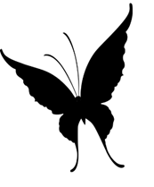  The power to solve this problem lies in the hands of landowners everywhere. Ninety-five percent of land in Illinois is privately owned. Individuals, not government, will determine the future of our ecosystem. Our home and business landscapes are a critical part of the conservation effort to sustain life on earth. |  |  | Plant Keystones  Keystone plants are native plants that have the most significant positive impact on the ecosystem.  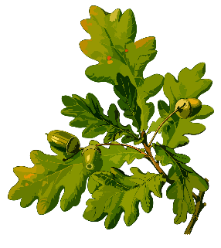  Keystone Plants in Our Area  Oak  Plum/Cherry  Goldenrod  Joe-Pye weed  Birch  Wild strawberry  Willow  Sunflower  Maple  Leadplant  For more information visit: sagmoraine.org |  |  | Landscape With Native Plants  People fear that native plants will not fit with their existing landscape. Many native plants are beautiful, non-aggressive, and make great additions to traditional landscapes.  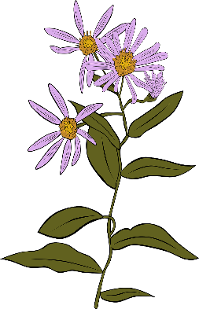  Native Plants for Traditional Landscapes  Riddell’s and Anise scented goldenrod  Purple coneflower  Blue false indigo  Black/Brown eyed Susan  Hibiscus rose mallow  Butterfly weed  Wild bergamot  Woodland phlox  Smooth blue aster  Anise hyssop  Wild ginger  Prairie dropseed  Little bluestem  Switchgrass  Prairie willow

